Assignment-2

Sandalpreet Kaur

Continental Institute For International Studies

IMDW-18008

Amandeep Singh

November 12, 2018

**Description**

Travelling train is the kind of website which allows the users to book the tickets from anywhere. It is the most helpful website for those who travels too much and need instant booking of tickets. It allows the users to know the time of the train at any time and any place. It ,very well may be utilized by everybody whether he/she is the traveller or the business in the railroad division. This site will give the straightforwardness among railroad and average folks. Its full access will be given to government . No one else could put their material in it . Moreover, it will give the best client encounter . People could make their very own record and get the extra focuses which could be utilized further to limit the ticket bills. There will be no compelling reason to remain in line for the extended periods just to purchase a ticket. this work will be of seconds which could spare clients time. Besides, this site will assist the clients with finding the coveted seat and know the correct planning of the train and in addition the status of the train with the assistance of GPS framework. Individuals could track their train in a matter of moments.

**Features-** This website includes various preliminary features. This website will provide the online ticket booking system. Train ticket booking enables the explorers to look for an affirmed compartment in the chosen class of a train. There are two different ways of booking train tickets: through railroad station ticket counters or online train ticket booking. One of a kind PNR (Passenger Name Record) is created against each ticket booked. This is another idea, whereby the client is helped by an accomplished IRCTC authorized operator amid the online train ticket booking process. Helped train ticket booking expels 90% pressure engaged with the booking procedure. The client gets imperative tips and counsel (which are sponsored by information) in each vital advance. For instance, if tickets are not accessible for your first decision train, the operator rapidly recommends an elective train (with similarly great execution and coordinating for the sightseeing designs) with high train ticket accessibility . Different highlights incorporate the presentation of affirmed tickets, information investigation to help select dates for movement and checking abuse of offices, for example, Tatkal. With the assistance of Indian Space Research Organization, the transporter intends to begin a component to dispatch SMS alarms to voyagers about entry, and take off of trains consistently. SMS alarms about postponements, reason for deferrals and the ETA of the train will likewise be sent to explorers, the report included. The other included highlights are the seat network which enables the customer to book the coveted seat. Travelling train, enquiry between two stations gives a rundown of every single accessible train for a specific course. It helps ticket purchasers make educated travel decisions. With a train enquiry between stations, done through a site or portable application, the travellers can get a review of all trains accessible for their movement course. IRCTC enquiry between two stations helps ticket purchasers channel train choices (according to their movement inclinations) for a specific course and take the best travel choice. The another component is Live train running status for railroad trains implies the correct area of any train and its continuous defer status. It might likewise incorporate the assessed landing of the train at a specific station on the way. The "Last Reported Station" means the station dependent on which the current live train running status is resolved. The "Last Reported Station" additionally passes on that the train has either arrived or left or crossed that specific station. The "Estimated Time of Arrival (ETA)" esteem passes on the normal time at which the trains should land at any of its up and coming stoppages. This is the time when the voyager at the up and coming is relied upon to be there to load up the train. The last reported station can be either a stoppage or a middle of the road station (where the train does not have a normal stoppage and essentially is required to cross the station). To add on, this site has the different page for the portrayal of train fares. A fare is the expense paid by a traveller for utilization of an open transport framework: rail, transport, taxi, and so forth. On account of air transport, the term airfare is regularly utilized. Toll structure is the framework set up to decide what amount is to be paid by different travellers utilizing a travel vehicle at some random time. A connected excursion is an outing from the beginning to the goal on the travel framework. Regardless of whether a traveller must make a few exchanges amid a voyage, the outing is considered one connected stumble on the framework.

**Purposes-** The main purposes of Travelling trains is that this site will give the online ticket booking framework. Train ticket booking empowers the pilgrims to search for a certified compartment in the picked class of a train. There are two distinctive methods for booking train tickets: through railroad station ticket counters or online train ticket booking. Diverse purpose consulate the introduction of certified tickets, data examination to help select dates for development and checking maltreatment of workplaces, for instance, Tatkal. It gives the full depiction of where the train will prevent and from where it will flight. it demonstrates the entire record on the site. The trains could be followed with the assistance of GPS framework from where one can watch the live status of the trains. It gives the adaptability in the terms of use. It is anything but difficult to work and can be utilized on different gadgets. Another motivation behind it is to give the tickets quickly . It will require just seconds to book the tickets. also the element of seat framework empowers the clients to pick wanted seat.

**Business model-** The people from whom the revenue will be generated can be advertisers which means publicizing is an advertising correspondence that utilizes a transparently supported, non-individual message to advance or offer an item, administration or thought. Supporters of publicizing are regularly organizations wishing to advance their items or administrations. Advertisers give money to those who advertise their product on their own websites. The other income created implies is client ostensible rental expense it is the lease concurred between gatherings which isn't identified with genuine esteem. Incorporates alleged "peppercorn" rents. Our resources will a chance to be those sites and physical saves alternately counters in the least significant stations. Our significant consumption will be acquisition over bulk, technology(software, streaming networking and so forth throughout this way, observing and stock arrangement of all instrumentation) , maintenance, stock Furthermore store space, protection operator and the A one may be misc. Additionally those accomplices of the website will a chance to be track sites, voyaging sites, travel magazines What's more on the web networking.

**Use case diagrams**

* **Administrator-**

Update train details

Carrier of goods

Operate communication system

Maintain Database

Figure 1*:* *Administrator*

* **Station Master-**

Updation of train timings

Staffing

Operates Signals

Figure 2 : *Station master*

* **Ticket counter-**

Make reservations

Maintain details

Print Tickets

Make cancellations

Figure 3 : *Ticket counter*

* **User-**

Registration

Pay for Fare

Check for ticket availability

Make cancellations

Make reservations

Figure 4 : *user*

**Use Case Description**

Make cancellations

Check for availability

Payment

Registration

Passenger . Banking system

Make registration

Maintain database

Online

Offlinetion

Ticket Counter

Reservation details

Print tickets

Railway Administrator

Update train status

Passenger details

Maintain details

**Use case description of Ticket Counter**

Those man who named toward ticket counter , he need exceptional responsibilities. He may be answerable for giving work to the tickets of the Travelers alongside it the ticket's reservation Furthermore cancellated is finished Toward those same man. Printing of the tickets What's more different support of the records need aid the sum under him. Keeping up those subtle elements incorporates reservation points Also reservation subtle elements.

**Content Plan**

1.

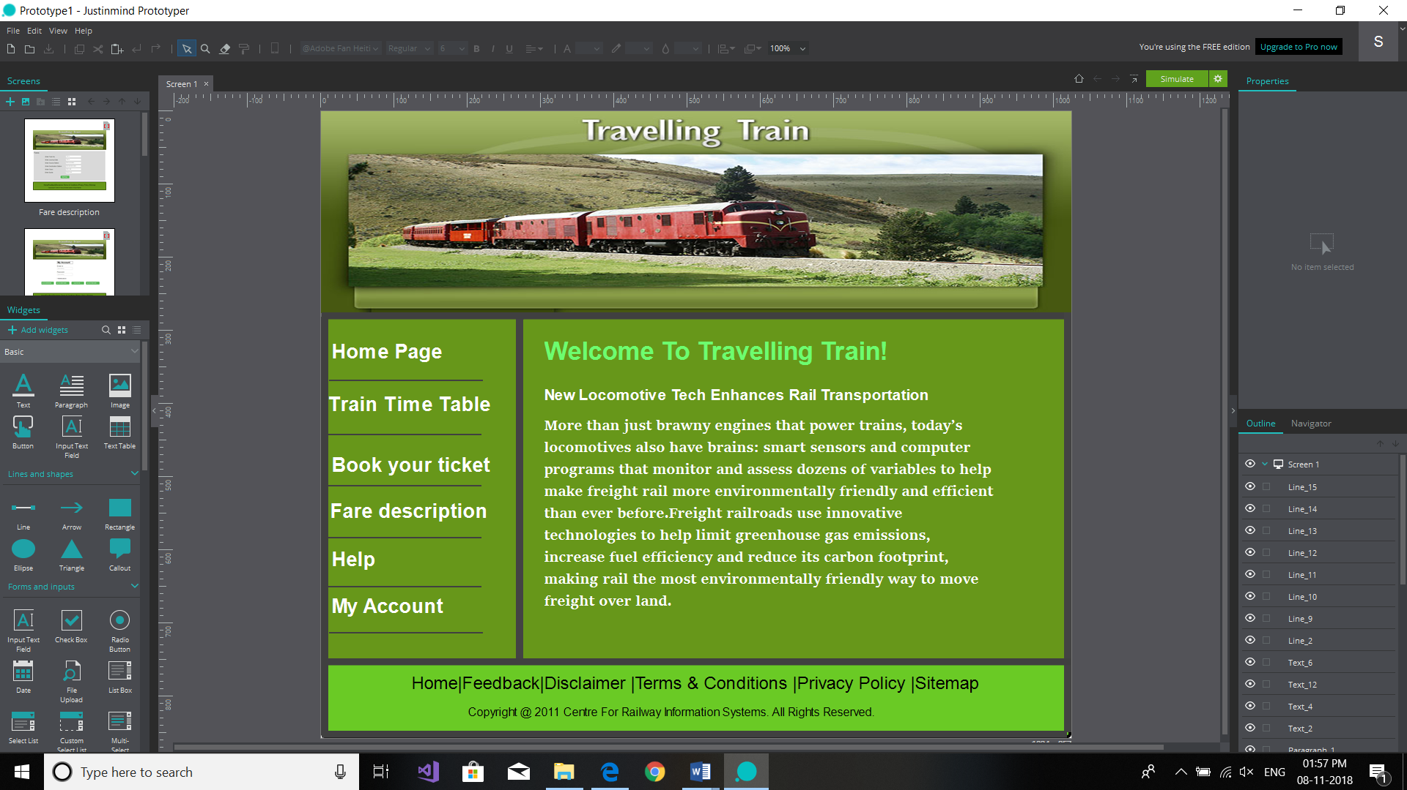

This is the aboriginal folio of the website called as "home page" it has the links to addition web pages which are train time table, book your tickets, fare description, help and my account.

2. 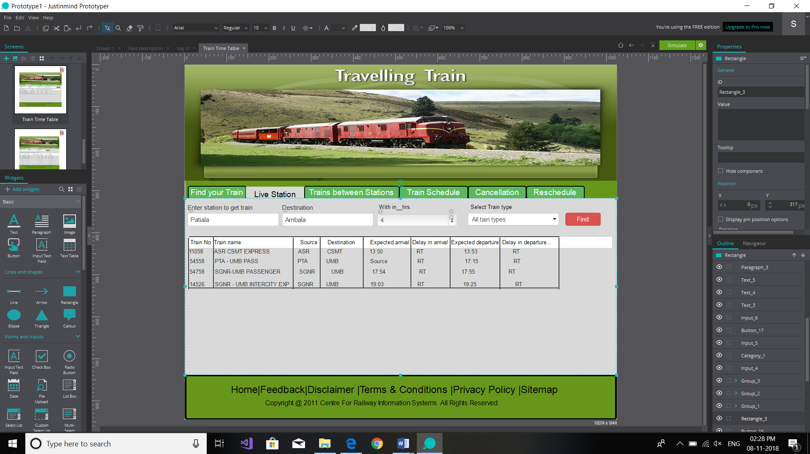

It is the second page of the website named as “Train Time table”. It includes find your train, live station, trains between stations, train schedule, cancellation and reschedule. This page shows how one can find his/her train just by putting one’s own station name and destination station and selecting the time in which one wants train . Another section is to select the train type. Afterwards user has to click find, then the screen will show all the trains in that particular time along with train no. and timing.

3. 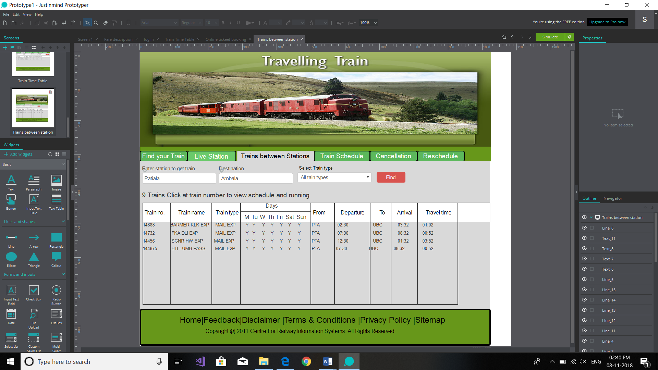

This is the another page which can be opened from second webpage- Train Time Table. It is named as – Train between Stations which involves the same input as previous page and gives additional information of train no., train name, train type. Days, from , departure, to, arrival and travel time. A person coud find the desired train from this page .

4.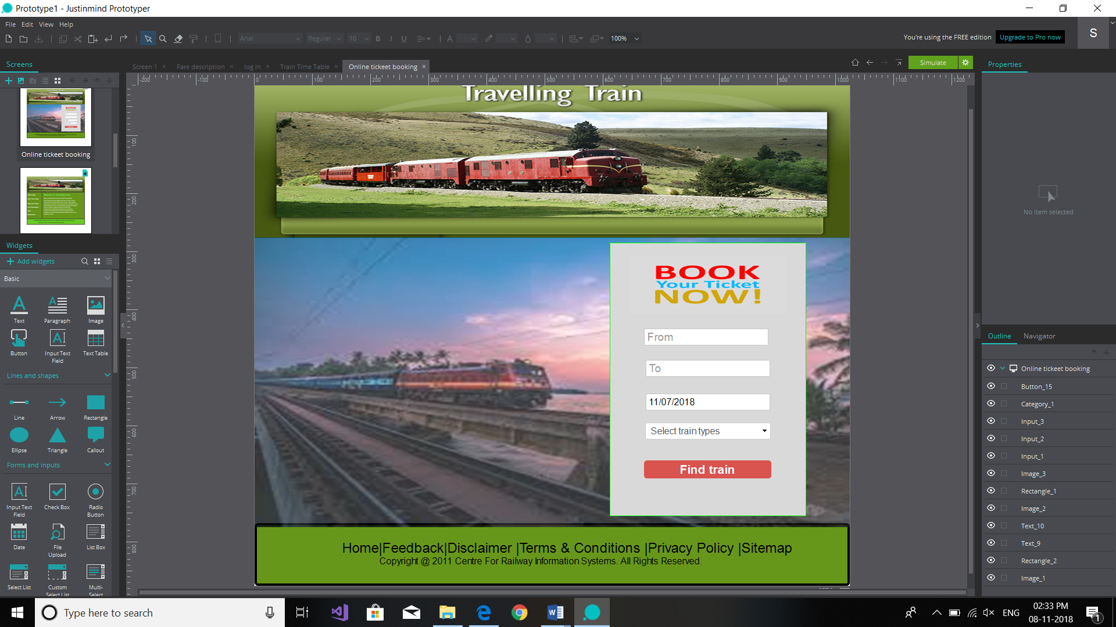

This is the fourth webpage for Online ticket booking. It includes the information which asks about the leaving station and destination station along with the date as well as the user is supposed to select train type.

5. 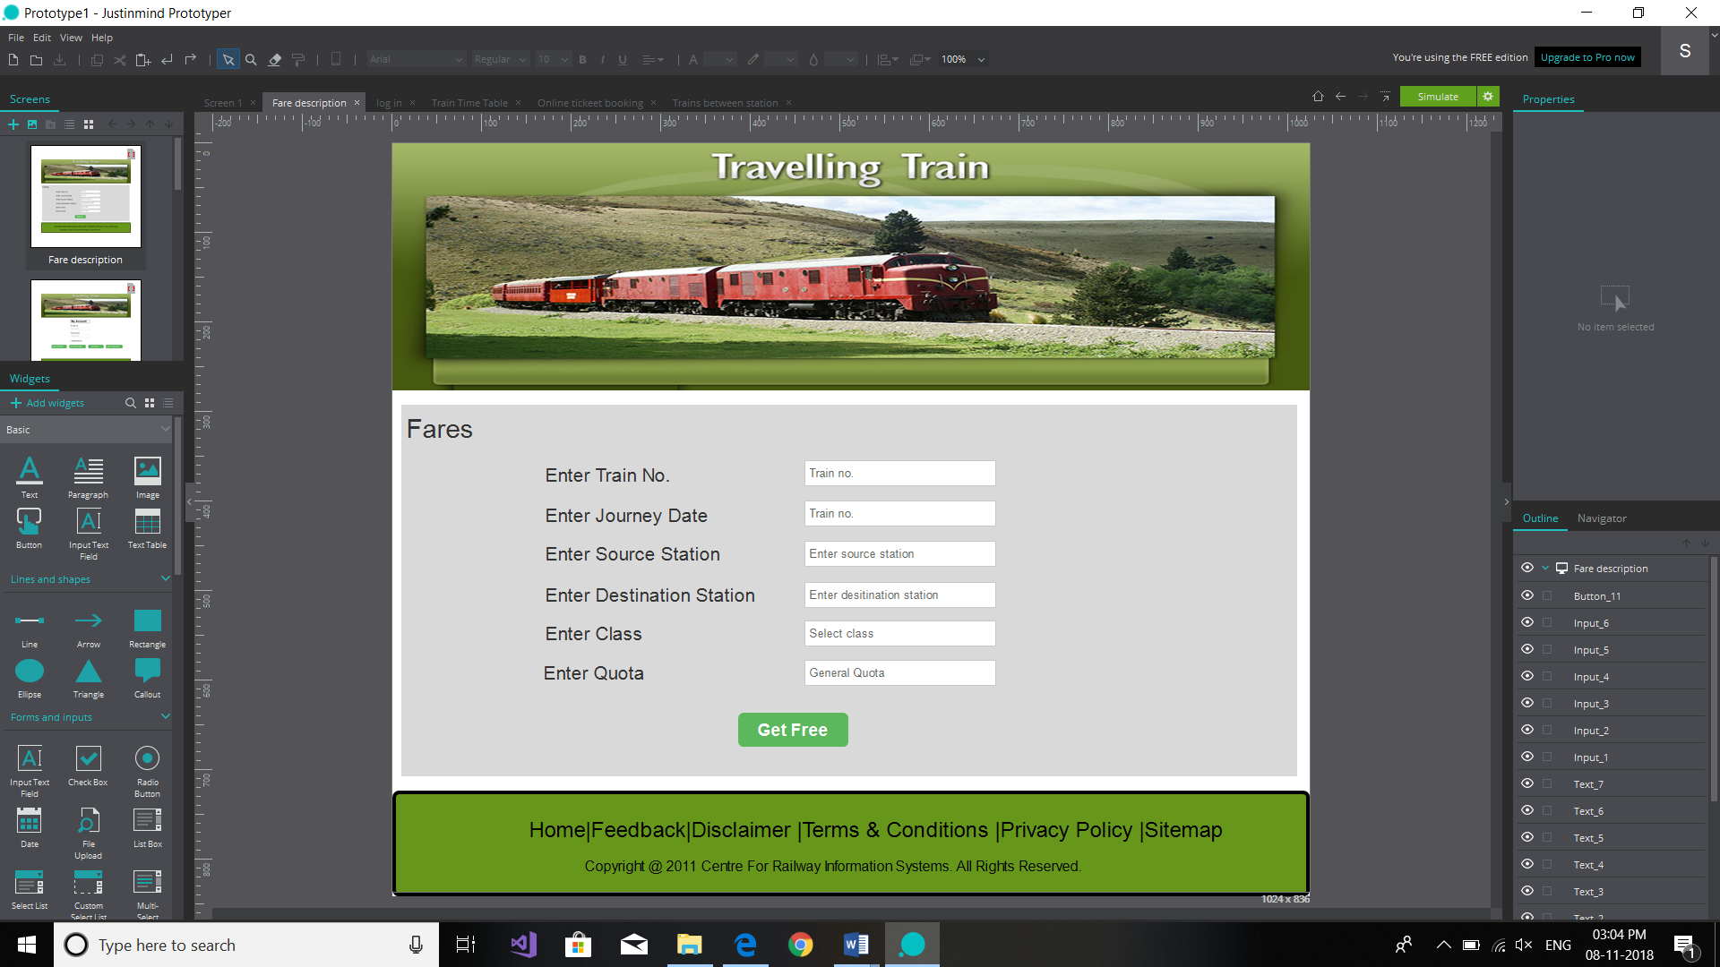

Fares description is the fifth webpage in the sequence. It holds the description of fares and asks the user for the train no., journey date, source station, destination station, class and quota. After entering all these details the user is directed to another webpages which has the description of the fare of that particular train is present.

6. 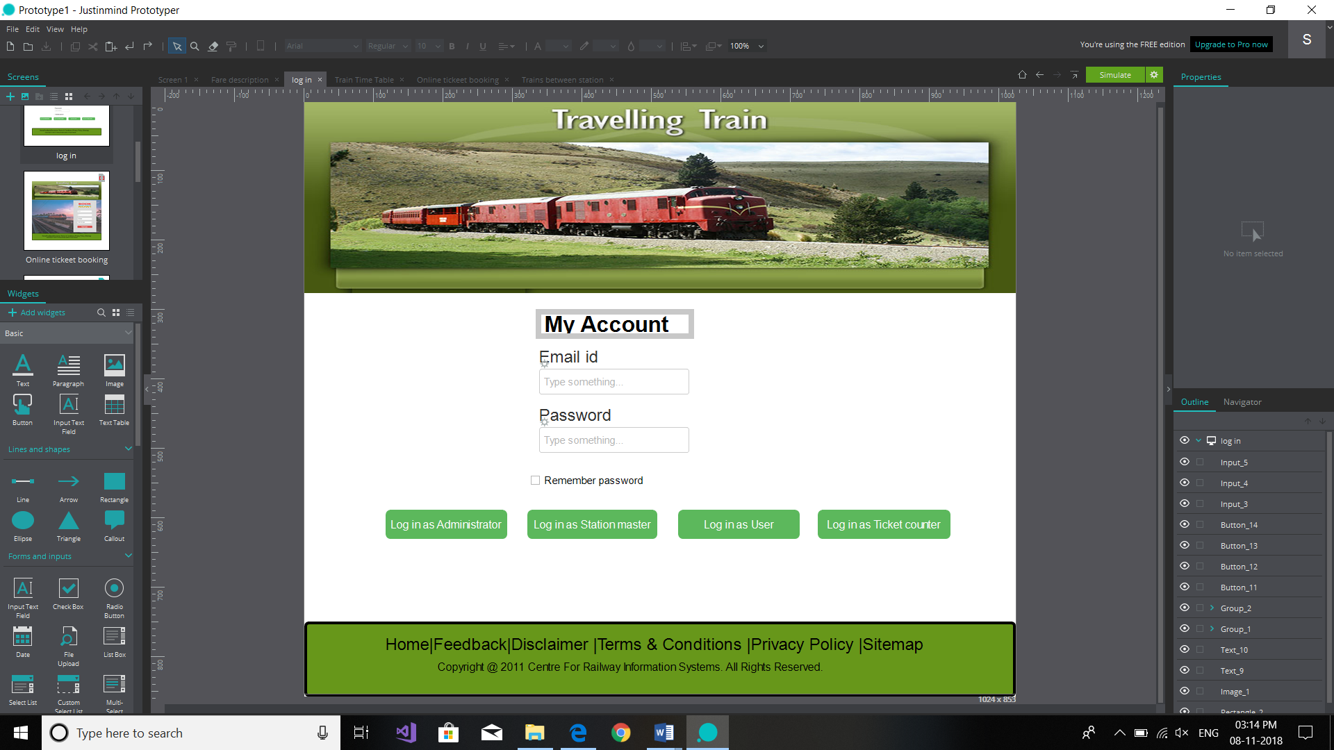

The sixth page of the travelling train includes the section for logging in for administrators, station masters, users and ticket counter persons. The person has to submit their email id and password to login to their profile for further working. The separate sections will be open for different persons as per their selection while loging in.

7. 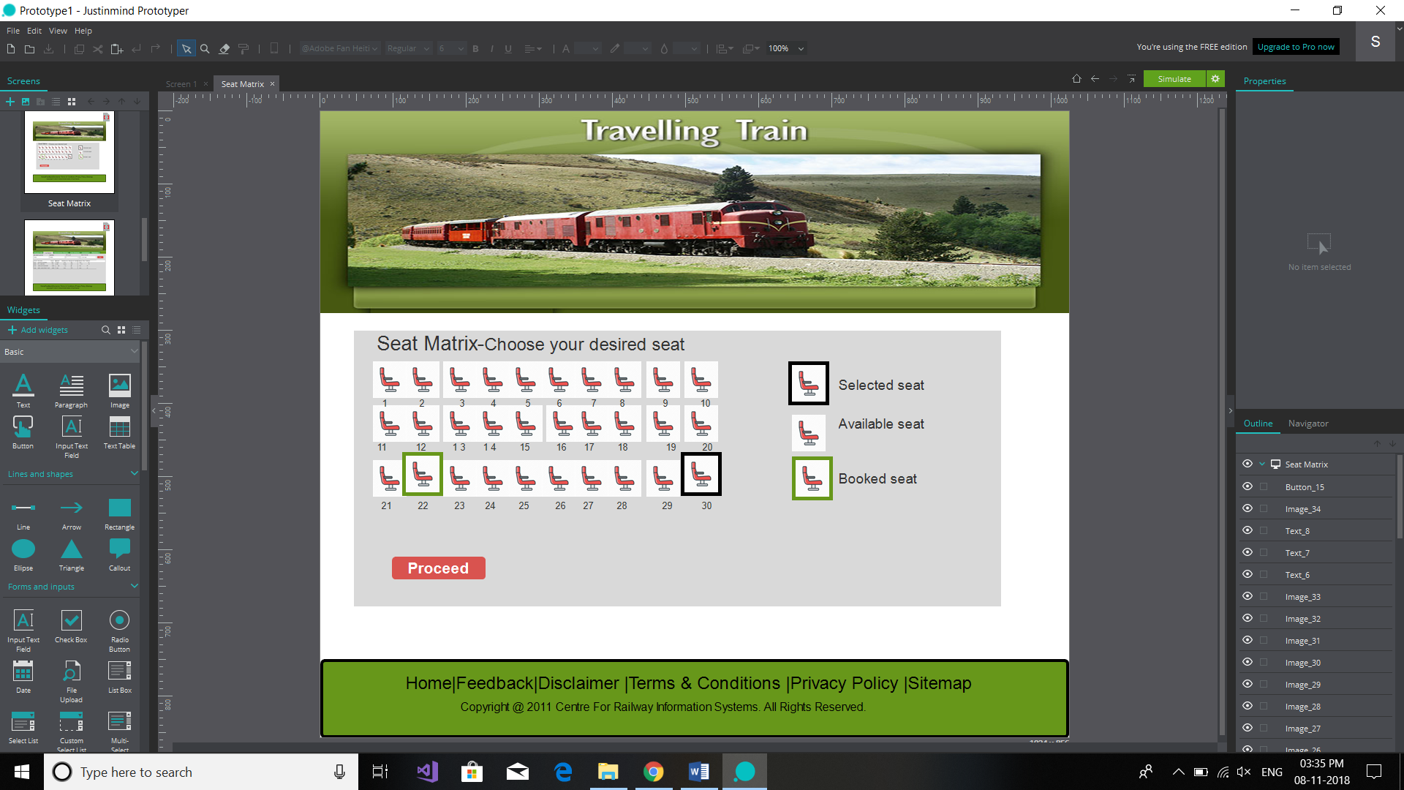

This page is devoted to the seat matrix of the railways from where one could select the desired seats. The seat which are outline with the green colour represents booked seat whereas those which are black outlined are selected seats by the users and rest are available seats. The user

will press proceedd button for the confirmation of the seats.